Constructors of ArrayList (Java)
- ArrayList al = new ArrayList();
→ Creates a new ArrayList object
→ Default capacity = 10
→ Size = 0 (no elements initially)

- ArrayList al = new ArrayList(int initialCapacity);
→ Creates an ArrayList with a given capacity
→ Example:

ArrayList al = new ArrayList(50);

→ Now capacity = 50 (better performance if you know data size in advance)

- ArrayList al = new ArrayList(Collection c);
→ Creates a new ArrayList by copying elements from another collection
→ Example:

ArrayList al2 = new ArrayList(al1);

→ All elements of al1 are copied into al2

When should we use ArrayList?

→ Use ArrayList when retrieval (reading data) is frequent

→ Reason:
- ArrayList uses index-based access
- It supports fast access using get(index)
- Because it implements RandomAccess

👉 Example use cases (real-time):
- Displaying list of users
- Fetching data from API and showing in UI
- Reading data frequently

When should we NOT use ArrayList?

→ Avoid ArrayList when insertion or deletion is frequent

→ Reason:
- Elements need to shift positions
- This reduces performance

👉 Example:
- Frequent insert at beginning
- Frequent delete from middle

→ In such cases, prefer LinkedList

RandomAccess Interface
- RandomAccess is a marker interface
→ Marker interface means no methods, no variables
- Purpose:
→ Provides fast access of elements using index
- Key idea:
→ Access speed is same for any position
→ Example:
  - 1st element
  - middle element
  - last element
→ All are accessed with same speed (O(1))
- Classes that implement it:
  - ArrayList
  - Vector

Cloneable Interface
- Cloneable is also a marker interface
→ No methods, no variables
- Introduced in JDK 1.0
- Purpose:
→ Allows object cloning (copying)
- Important point:
→ Used to create a duplicate object without using new keyword manually

🔥 Real-Time Insight (Very Important)
- ArrayList → Best for read-heavy applications
- LinkedList → Best for insert/delete-heavy applications

👉 In real projects:
- 80% cases → ArrayList is used (because reading data is more common)

✅ What you said:

interface RandomAccess { }

✔️ This is correct in structure
→ A marker interface looks empty like this

⚠️ But here is the important correction:

A marker interface is NOT just “any empty interface”

👉 It has a special purpose:
It marks (tags) a class, so the JVM or Java libraries treat that class differently.

Simple Definition

A marker interface is:

An empty interface (no methods) used to give special meaning or behavior to a class.

Example: RandomAccess
- RandomAccess is a marker interface
- It tells Java:
→ “This class supports fast random access”

👉 Example:

ArrayList list = new ArrayList();

→ ArrayList implements RandomAccess
→ So accessing list.get(5) is fast

Example: Cloneable
- Cloneable is also a marker interface
- It tells Java:
→ “This object can be cloned”

👉 If a class does NOT implement Cloneable:

obj.clone(); // ❌ Runtime error

🔥 Key Difference (Important)
Concept | Meaning
Empty Interface | Just no methods
Marker Interface | Empty + gives special meaning/behavior

👉 So:

Every marker interface is empty
❌ But not every empty interface is a marker interface

🎯 Simple Analogy

Think of marker interface like a “tag or sticker”
- RandomAccess → “Fast access allowed” tag
- Cloneable → “Can be copied” tag

Eg: ArrayAndArrayList
// go through the code

Eg: ArrayList_Eg1
// go through the cide

Eg: ArrayList_Eg2

// go through the code

Eg: ArrayList_Eg3

🔥 Simple Rule

removeAll(c) → removes everything in the list that is also present in c

✅ Example 1 (Easy)

ArrayList<Integer> al = new ArrayList<>();
al.add(10);
al.add(20);
al.add(30);
ArrayList<Integer> c = new ArrayList<>();
c.add(20);
c.add(30);
al.removeAll(c);
System.out.println(al);

👉 Output:

[10]

✔️ Because:

20 and 30 are common → removed

10 is not common → stays

Eg: ArrayList_Eg4

✅ What retainAll() does

al.retainAll(c);

👉 It keeps only the common elements
👉 It removes everything else

🔥 Simple Rule

retainAll(c) → “Keep only elements that are also present in c”

Eg: ArrayList_Eg5

// go through the code

Eg: ArrayList_Eg6

// go through the code

LinkedList

👉 What is LinkedList?

LinkedList is a class in Java.

It is an implementation of the List interface.

It is available inside the java.util package.

👉 Syntax (Definition)

public class LinkedList
extends AbstractSequentialList
implements List, Deque, Cloneable, Serializable {
}

✔ Meaning:

It inherits behavior from AbstractSequentialList.

It implements multiple interfaces like:

List → allows storing elements in order

Deque → allows adding/removing from both ends

Cloneable → allows object cloning

Serializable → allows object to be converted into byte stream

👉 Internal Data Structure

LinkedList uses a Doubly Linked List internally.

In some cases, it behaves like a Circular Linked List.

✔ Simple understanding:

Each element (node) contains:

Data

Reference to previous node

Reference to next node

👉 When was it introduced?

LinkedList was introduced in JDK 1.2 version

🔥 Simple Real-Time Understanding

Elements are not stored continuously (not like ArrayList)

Each element is connected using links

Good for:

Frequent insertions and deletions

Not good for:

Random access (like get(index) is slower)

Properties of LinkedList (Simple Explanation)

1. Index-based structure

LinkedList also uses index positions like 0, 1, 2…
👉 First element is always stored at index 0

2. Allows different data types (Heterogeneous)

You can store different types of values in one LinkedList
👉 Example: 10, "Deepak", true

3. Allows duplicate values

Same value can be stored multiple times
👉 Example: 10, 20, 10, 30

4. Allows multiple null values

You can store any number of null values
👉 Example: 10, null, 20, null

5. Maintains insertion order

Elements are stored and retrieved in the same order you insert them
👉 If you add: 10 → 20 → 30
👉 You will get: 10 → 20 → 30

6. Does NOT follow sorting

LinkedList does not sort elements automatically
👉 It keeps data as you insert it

7. Non-synchronized

LinkedList methods are not synchronized
👉 Means no built-in thread safety

8. Multiple threads allowed

More than one thread can access LinkedList at the same time

⚠️ But this is not safe

9. Parallel execution possible

Since it's not synchronized, multiple threads can run operations in parallel

👉 This improves performance
👉 But may create issues

10. Faster execution (in some cases)

Because no synchronization overhead
👉 Operations can be faster compared to synchronized collections

⚠️ Especially useful in single-threaded applications

11. Not thread-safe

If multiple threads modify it at the same time
👉 Data can get corrupted

12. No guarantee of data consistency

Because of lack of synchronization
👉 Data may become inconsistent in multi-threaded environment

Working of LinkedList (Simple Explanation)

1. Types of LinkedList

a) Singly Linked List

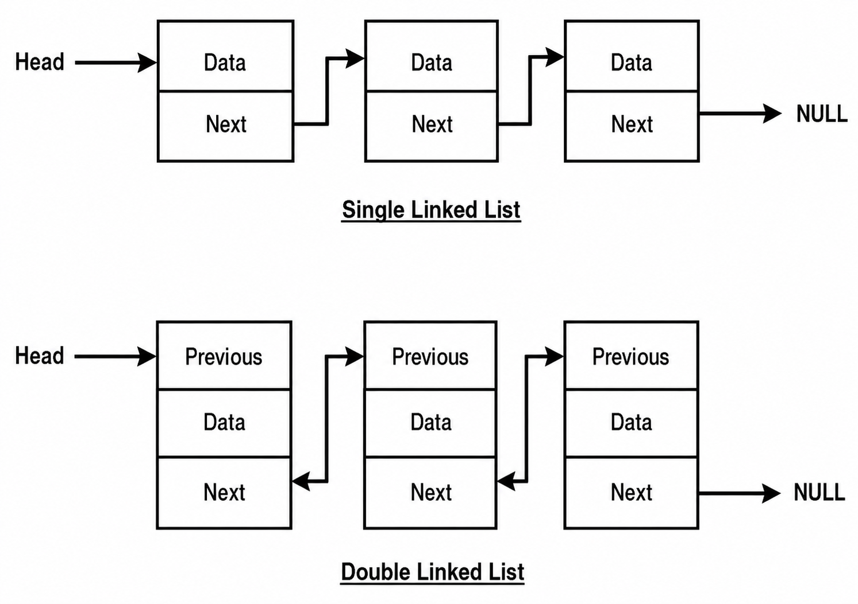

Each node stores:

Data

Address of next node

Moves only in one direction →

b) Doubly Linked List

Each node stores:

Previous address

Data

Next address

Moves in both directions ← →

c) Circular Linked List

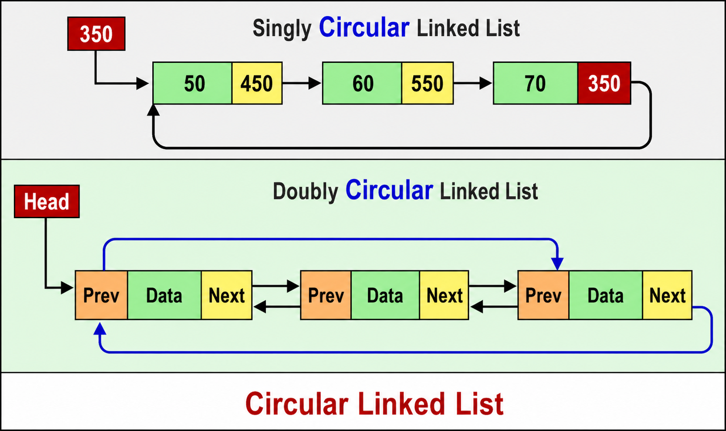

Last node connects back to first node
👉 Forms a loop

2. Non-contiguous Memory (Very Simple)

❓ What it means

Elements are NOT stored next to each other in memory.

👉 Instead, each element (node) is stored somewhere else, and they are connected using links (addresses).

🧠 Think like this:

ArrayList (Contiguous)

[10][20][30][40]

All elements are side by side

Like seats in a row 🎭

LinkedList (Non-contiguous)

[10 | next] → [20 | next] → [30 | next]

Each element is in a different place

Connected using pointers

3. No Capacity Concept (Very Simple)

❓ What it means

LinkedList does not have a fixed size

👉 It can grow as much as you want

🧠 Compare with ArrayList

ArrayList

Has capacity

Example:

Capacity = 10

If full → needs resizing (costly)

LinkedList

No capacity at all

Every new element = new node created

📦 Real-life example

ArrayList

Like a bus with 10 seats 🚌

Once full → no space

Need another bus (resize)

LinkedList

Like a train 🚆

You can keep adding coaches

No fixed limit

💡 Example in Java

LinkedList list = new LinkedList();
list.add(10);
list.add(20);
list.add(30);
list.add(40);
list.add(50);

👉 You can keep adding unlimited elements (until memory is available)

Constructors of LinkedList

1. public LinkedList()

👉 Creates an empty LinkedList

2. public LinkedList(Collection c)

👉 Creates LinkedList using another collection

Example:

LinkedList list = new LinkedList(existingCollection);

